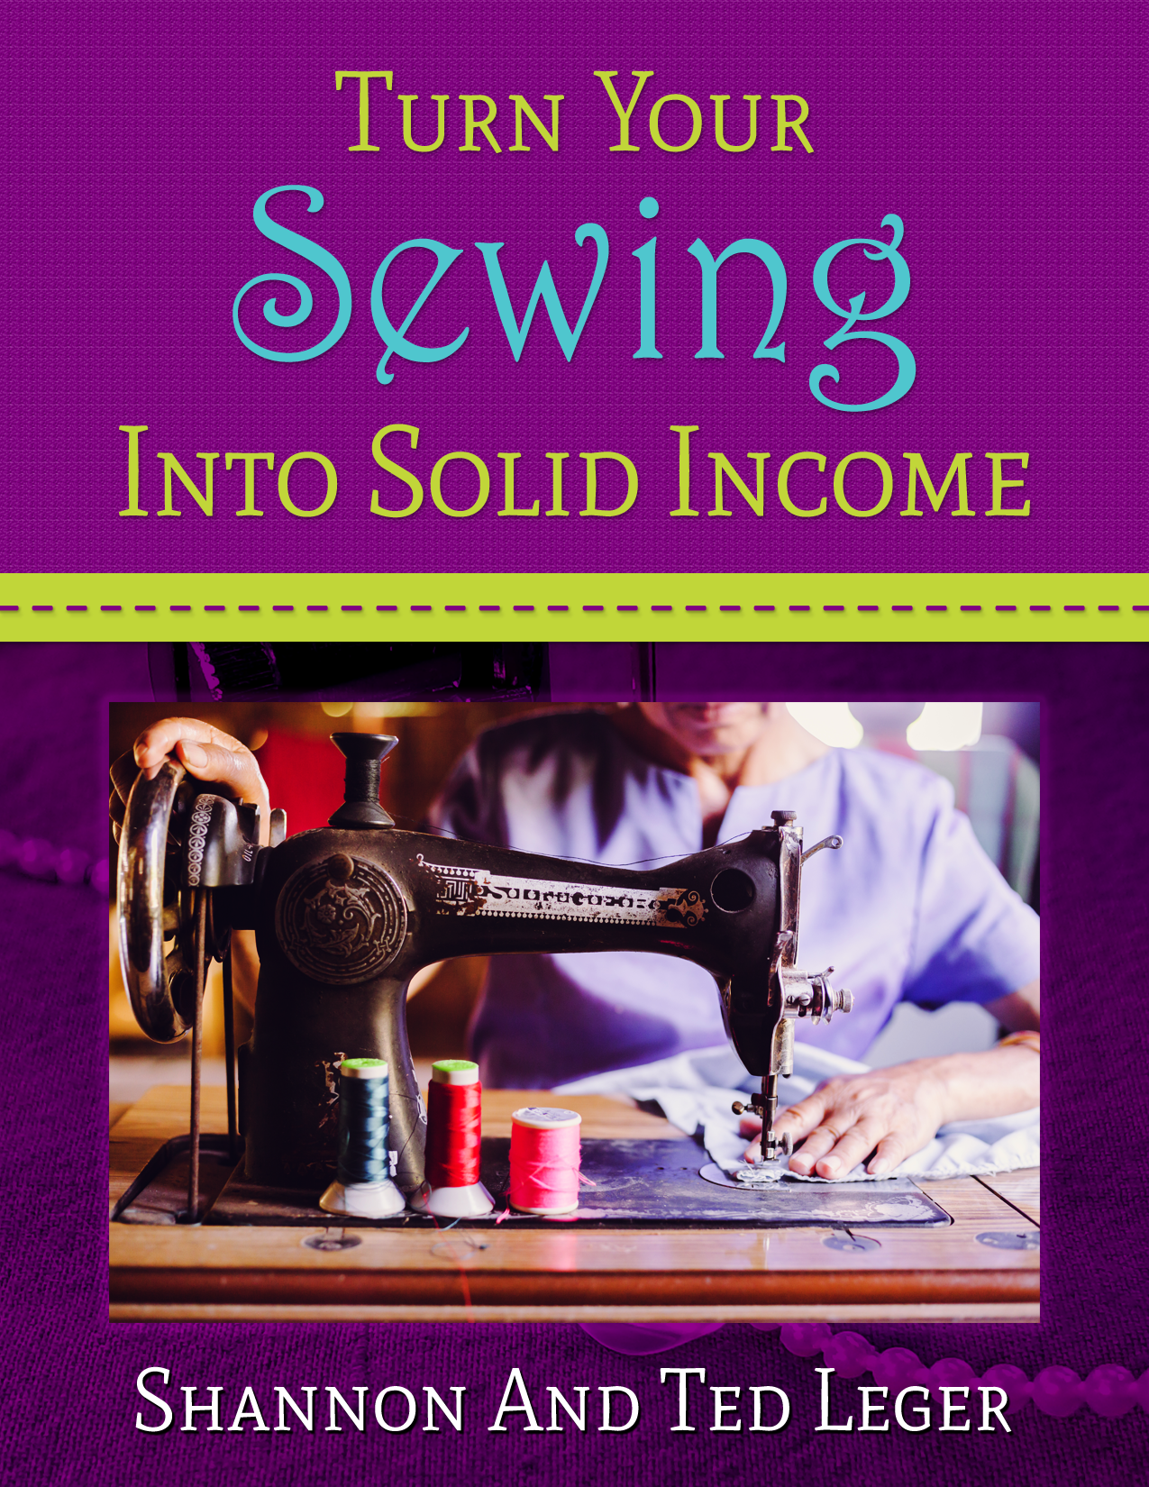
Contents
INTRO 3
CHAPTER 1: GETTING STARTED 4
CHAPTER 2: HOW THE INTERNET HAS CHANGED THE WORLD - AND CAN CHANGE YOURS 7
CHAPTER 3: A SUCCESSFUL BUSINESS TAKES MORE THAN INTELLIGENCE, TIME, AND EFFORT 9
CHAPTER 4: EBAY AND OTHER LISTING SITES 10
eBay 10
Completed And Sold Listings 10
CHAPTER 5: BUILDING AN ONLINE PRESENCE 16
WORDPRESS 16
PAY PER CLICK ADVERTISING 17
SHOPPING ENGINES 17
CHAPTER 6: USING SOCIAL MEDIA TO CREATE CUSTOMERS 19
POSTING WITH SOCIAL MEDIA 21
POSTING INFORMATION? SO WHAT? WHAT GOOD DOES THAT DO? 21
CHAPTER 7: FINDING DROPSHIPPERS FOR PHYSICAL PRODUCTS 23
IN CONCLUSION: WHERE WILL YOU END UP? 25

INTRO

Hi, this is Shannon and Ted Leger. We have been married now for 20 years, and work together online.

We have to start by giving you a little insight into who we are, because once you realize what kind of a people we are as a couple, you will see that you don’t have to be an internet guru or own a closet full of power suits in order to have your own business. Even when it comes to a very successful internet business, doing something you LIKE to do - either full time or on the side. We know you want to get to the punch, so this will be brief.

Shannon - I have been sewing for over 5 decades. I worked on my own contracting for an interior designer, and sewed for many different people.

Ted - I am an average, everyday individual. What you read here isn’t going to be coming from an internet super genius, or a someone that has risen to success because of special training, or has a business degree.

Through time and patience I established a business online, using my hobby of woodworking as a full time income.

This ebook will combine the knowledge of both Shannon and myself’s experiences in order to help you to begin making money with any hobby. So let’s get started.

Shannon - Though I was considered a good seamstress for a long time, it took decades before I figured out how to turn it into a good business.

Ted - Unlike Shannon, I still have yet to find my niche – something that I am better than many at. In fact, I actually don’t know if I will find it. I have a certain amount of success with many different things at different levels. Some say that IS my thing. Maybe. But enough about formalities. Let’s move on.

CHAPTER 1: GETTING STARTED

Ted - I am not an expert in my hobby. And I am also not an expert businessman, internet marketer, salesman, etc.. Yes, over years, I have learned many things that a beginner doesn’t know.

But that is more EXPERIENCE than just picking it up and flying with it. I have worked in many different fields such as industrial work, home improvement and remodeling, I was a satellite television technician, and finally ended up building and selling outdoor furniture online.

You are probably stopping right there and saying that this is about sewing as a business. But please read on because my experience selling online products, combined with Shannons has much to offer those desiring to sell any handmade item. So let’s start with her first, since she is a seamstress and odds are that is the direction you are taking with your endeavors:

Shannon - I personally sold items that I made, but eventually I also used my skills as a seamstress to not just sell handmade products such as baby bedding and embroidered bags (such as totes and diaper bags, but also I contracted myself to an interior design shop.)

The one I found made it simple because they needed someone to make curtains for them. Because of this, I still was able to work from home. I would go out to the job and take the measurements, but then would do all the work from my shop at home.

As a note: You don’t have to have a shop to sell your products or services. Just a dedicated space where you can sew.

If you are looking for an easy item to make, a simple tote with colorful fabrics is a good place to start. If you would like to cheat, then you can buy one you like and take it apart to get the measurements and sizes.

Or you can get a few of them to have more of a variety to sell. Once you get the process down pat, not only will the money be better the entire method will be easier because you then can make these products quickly.

Making the same items over and over may seem dull, but it’s not. Not when it is your business. This is because when you work for yourself, you are trying to beat the clock. You earn more income that way. Where as if you are working for someone else, you are riding the clock, and it’s not exciting and very boring.

Ted - With the outdoor furniture business I handled both the business end and worked in the shop for 8 years, having upwards as many as five people working with me manufacturing everything. To give you an example of the success of the business, there were a few years that I sold almost 2000 porch swings on the internet. All at retail prices. Now don’t get too excited, the first year I only sold 300 swings online. The majority on eBay. But being in the black from the get go, I saw the potential of the business.

Almost a decade after starting the business, my health started to fail though. Because of this, I had to give up working in the shop. But the business continued. I have pursued other online endeavors so all of my eggs aren’t in one basket. How is that possible? I found someone to do the work for me at a wholesale price, and I just handle the business end, selling online at retail.

This business was successful only because of the internet. I tried something similar a few years prior and it didn’t go so well. When we first started working for ourselves a short time after the year 2000 hit, there weren’t near the opportunities that are out there now. We wanted to make some extra money on top of my regular 9-5 job, so I took the skills that I acquired from a few years of woodworking and started building some outdoor furniture.

Because of my love for my hobby, I was able to take what I loved to do and turn it into income. For those that are more beginners in anything like this, even sewing, you don’t have to make extravagant, expensive, or complicated items and products for them to sell. I personally made outdoor furniture, which is much faster and easier to create in comparison to say - cabinets.

The point? I made what is considered simple with what I was passionate about - yet these items sold. So, I went with it.

One thing to keep in mind is that I pursued woodworking because it was my hobby and passion. It isn’t woodworking that you want to pursue, but you can take this same strategy and run with it yourself in any endeavor. It’s sewing. But for the sake of time, I will use my experience with what I personally did, and you can draw from it and add it to your solution.

It actually started out ok. Nothing spectacular, but I did sell quite a few things. I sold locally, had an ad in the classifieds, and went to the local trade days that happened once a month in our area. It was a large property that had a lot of different booths or spots that you could rent out and sell your “stuff.”

I even got a couple of the individuals that were at the trade days to start buying my furniture in order to sell at other markets they went to. Some of these individuals had a circuit they travelled with different festivals. The problem though was I was already working 6 days a week at my “regular” job at a plywood manufacturing mill, and so I was exhausted physically and mentally. I wanted to go into it full time, but another issue was in the way. Where I lived.

I lived in a rural area, and there weren’t that many people around in comparison to a city. So the traffic was not there to make enough money to do it full time. (It’s funny that I use the word “traffic” now, because back then I just thought of it as not enough people in our area for enough customers. Working online over a few years tends to change your speech patterns.)

Anyway, so I did it for a time, then just gave it up. I was too tired. My regular job was already exhausting, and it was a graveyard shift. Therefore, I had that against me as well. A few years later though I rebooted the business and it worked this time. Why? What changed?

I still live in the same rural area, and for the last decade or so, I have been able to have this business of selling furniture running non-stop, and there has never been a time that I went without any orders pending. What was the difference between now and when I first gave it a whirl?

This time, I did some research. In the following chapter, I will show you how to do similar research with ANY product that you would like to sell, even if you don’t want to turn your hobby into a career. Again, this can be something you can turn into a full time path or part time job for some extra income.

And here is the kicker. I guarantee that many reading this are BETTER than I am at woodworking, and probably have had more experience in the shop as well.

CHAPTER 2: HOW THE INTERNET HAS CHANGED THE WORLD - AND CAN CHANGE YOURS

This world has changed rapidly over the last few decades. This generation has been growing up looking at everything differently than the generation prior to them. From careers to making music, the introduction of the internet has changed much of the structure of this planet’s arrangement of things and lifestyle. One thing we do want to say before going any further is this: DON’T let talking about selling online scare you away from doing so. It isn’t as difficult as you would think. And if worse came to worse you could always have someone help you.

Whenever it became available to just about anyone, the amount of new people online increased at such a fast pace that it really only took about 6-8 years for it to change the entire world. Not only did the internet put knowledge at your fingertips, it also introduced the realm of ecommerce, or the internet market.

Without the reach of the internet, we could never have gone into business for ourselves. Once again, if you are living in an area that doesn’t have many people, it is very difficult to sell anything. Especially if what you are trying to sell is a product. Even if you live in a large city, that still doesn’t mean that you will have a large enough population seeing what you have for sale. This is definitely not the case with the internet because you have the potential of the entire world becoming your customers.

If you have a niche product, that is even worse without having a business online. You already have a limited amount of individuals that will even look at your inventory. But since the explosion of this channel, you are able to reach many, many more buyers than without it. Sometimes the niche product would never get even one sell unless it WAS online.

Ted - I had a friend of mine that had a piece of equipment that would cut metal sheets. It was a big piece of equipment, and expensive. He asked me if I could try to sell it online for him. Within just a few days of being listed on eBay, it sold. And I don’t mean a few days like those that say a few days and mean a few weeks. It was literally 2-3 days after I listed it. How long would he have had to wait for someone to buy it, IF someone would buy it in this rural area? Even if you put it in a newspaper for sale, what are the odds of something like that selling quickly? It’s hard to tell.

The point is that now that the internet has gained such popularity worldwide, then you almost always have to have an online presence if you have a business. Having just a brick and mortar store doesn’t cut it anymore. Nowadays, just about every business that sells in a retail outlet is also selling on the internet. Big businesses such as Walmart, Sears, Lowes, and any other outlet will sell online in addition to what they have in their store. And since everyone is on the internet, you will have to put your store on as well if you want to keep up.

Also there are cheaper opportunities of starting up a business online because you have more things that can be done for a business at home. You can establish it in your own home as well. You can start small and grow, whereas it used to be you had to start big with many businesses, have a ton of inventory, etc.. and HOPED that it would work out in such a way that you will be able to get the company in the black within a few years.

Ok, now that you see the importance of taking any business online, what do you have to do first? You have some options, but we don’t want to throw too many out there. If you are just getting started you don’t want too many decisions to have to make because that is just too confusing. So we will stick to a basic outline.

CHAPTER 3: A SUCCESSFUL BUSINESS TAKES MORE THAN INTELLIGENCE, TIME, AND SKILL

With any business to be what many consider “successful,” it DOES usually take some intelligence, time, and skill. So don’t let the name of the chapter fool you. But – it usually takes more. Yes, there are those fortunate few that a great business just falls in their laps, but we are talking about the majority here.

Think about it, if that is all it took, many more people would be working at home, and not for someone else than what you see today. Look at how many workaholics aren’t considered “successful” with their endeavors. There is a reason for this.

Have you ever heard the phrase, “Knowledge Is Power?” This is without a doubt a truism. The majority that ride the stock market and are successful with it have become that way because they have knowledge of the different markets out there. You can’t just go in there blindly and think you will make money. There is so much you have to know and research.

The same is with any business. You have to do a wealth of research before you know if something is going to work out or not. Without doing so you are striking at the air. We are going to take a look at a few markets and use these as a basis for your research. You are going to want to go with well-established ones for the research, because that is how you find well established data.

Ted - Let’s start with where I started……

CHAPTER 4: EBAY AND OTHER LISTING SITES

eBay

We will start here. Ebay or “eBay” as it is normally spelled, has been around since 1995. So that is a great start with the research. They have many established buyers and sellers that have been selling for years on eBay.

Similar sites such as Amazon have similar methods of figuring out what is selling online. It would take many pages to show you every marketing site’s methods. But you can use eBay first and then figure out the others from there, because they are going to be similar.

Here is one method of figuring out if what you have to offer will sell or not:

Completed And Sold Listings

You have to have an eBay account in order to find out what is selling on their site. It is absolutely free, so if you don’t have an account, just sign up for one. Once you have signed up, then you can get started.

NEVER! NEVER! NEVER! Look at what is selling on eBay and the pricing and think that is what is selling. That is just a listing. The seller could have a thousand listed items and is not selling anything, if much at all. Especially because eBay has now decreased their listing prices to next to nothing if it doesn’t sell, so a seller can list many items now without losing their shirt.

Ted - It wasn’t that way when I started. When I was selling my products on eBay back in 2005, it cost me almost 10 dollars to list one item. Even if it didn’t sell, then I still had to pay eBay the 10 bucks. That was steep, but the door swung both ways. It was good because that meant you had less competition back then, and if you had a niche product, you got a good bit of the market to yourself. But then again, you could lose money if your products didn’t sell. So six dozen of one half the other…..or however you say that old phrase.

Now that this has changed, you can list products for dirt cheap, and if they don’t sell, then you haven’t lost much, if anything at all. The problem though is anybody and everybody sells on eBay now because of that. Therefore you have more competition. But enough about that, we are just trying to see if your product is selling. We will use porch swings as an example, because that is what I started with. So here is what you do. Type in “porch swings” in the search bar on eBay. Like so:

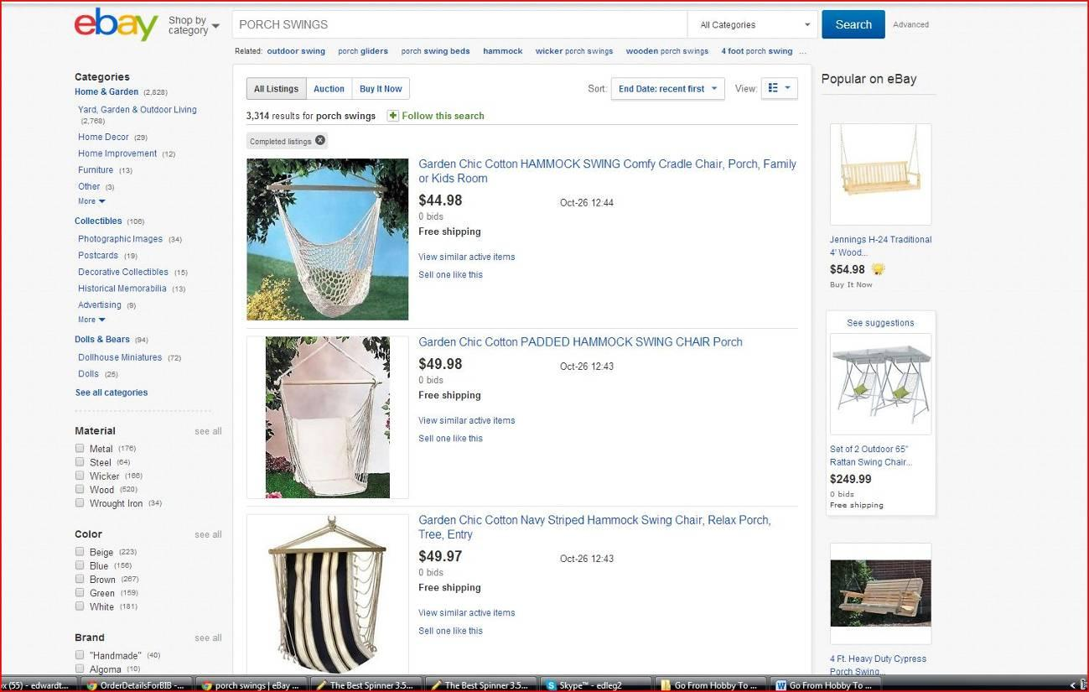

Again, don’t ever look at the listings and say “HEY! Look at how much this is selling for!” That isn’t how it works. You want to see if an item sells, and sells well. So you need to make sure that you are signed in on eBay, and then go to the completed listings box on the left hand side of the page.

You could go with “sold listings” underneath “completed listings,” but the problem with that is you want to see the ratio of how many items are listed in comparison to how many sell. So go with completed listings first as you see below:

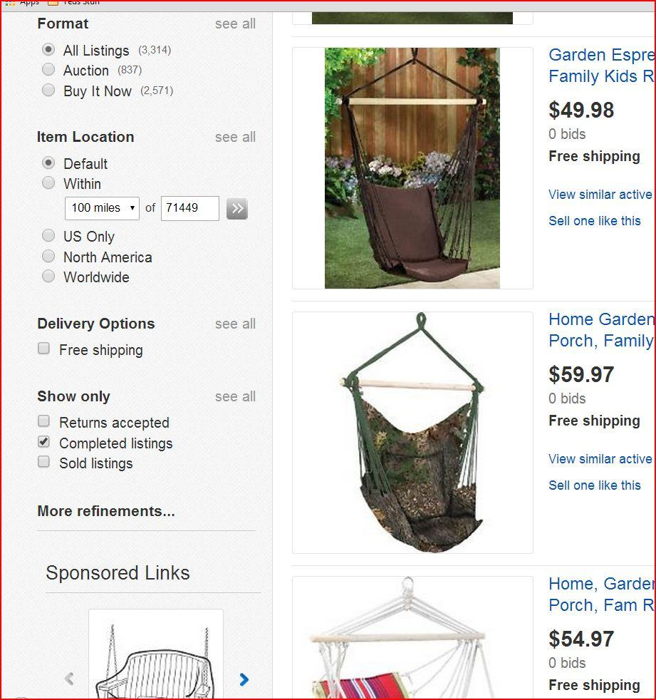

Once you check the “completed listings” box, it will bring up the past two week’s worth of listed items that you have put in the search box. It will tell you what has sold by the price highlighted in green like you see in the following image:

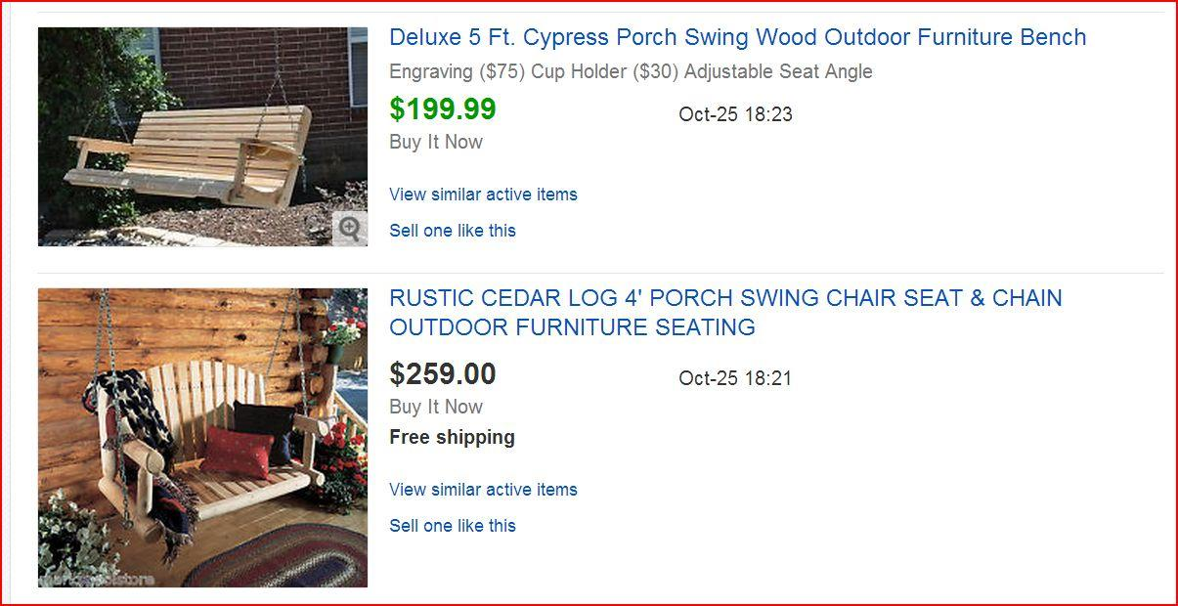

Take note that the swing that has the highlighted price in green is one that sold. The one in black did not. Now what you can do is go see how many this seller has sold on eBay in the past two weeks. To do this, just follow these steps:

- Click on the link to the seller’s page. If you are new to eBay, it is going to be to the right of the picture – the Title of his item: “Deluxe 5 ft. Cypress Porch Swing Wood Outdoor Furniture Bench.” Alternatively, just click the image of the item he or she is selling.

- Once you get to the page, on the right hand side, you will see the “Seller Information.” Below it you will see his or her feedback, etc.. Go a little lower to “see other items” like in the image that follows:

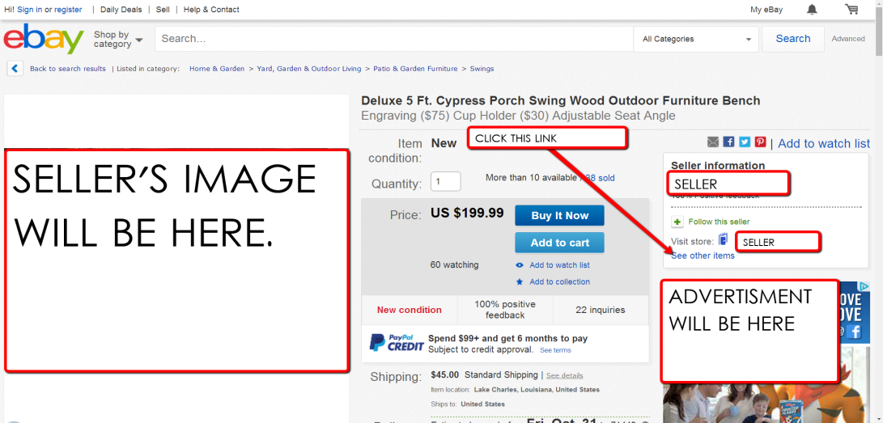

Once you go to the sellers other items, go back to the “completed listings” options and check it again. Once you check the “completed listings” box this time, you will see that it has now given you all of that seller’s items that have sold or haven’t sold.

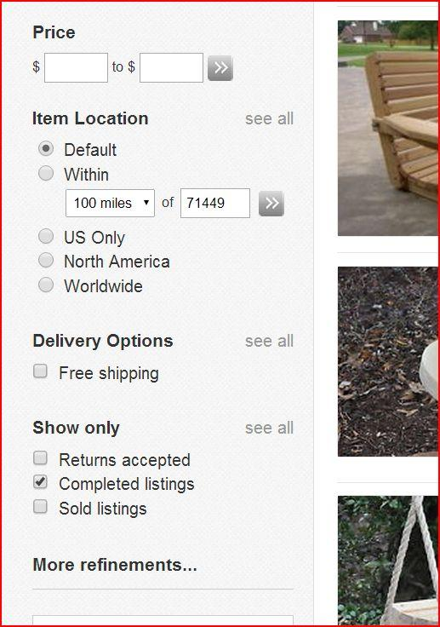
There are going to be a number of things that you have to look for. You can’t just do this one time and say, “I know what to do now. Sell porch swings.” It doesn’t work that way.

You have to look at every aspect of the item. For example, with this one, you look at the material that the porch swing is made of. His is out of cypress wood. This poses an issue for many. Unless you live in the lower states, odds are you aren’t going to be able to get your hands on that material.

Fortunately, we DO live in the south, so I was able to get my hands on cypress without any problem. However, it doesn’t just end there. You have to check other aspects such as the grade of lumber. In this case he uses “select” cypress, which is 99 percent knot free.

Then you have to check on the style of the item. Is it branded, what does it sell for, and everything about it overall. Once you have done this, you have to check other sellers with similar items and see if they are having a successful amount of sales as well. I looked into everything on the items. I checked cedar furniture, treated pine, oak, and others.

The cypress wood outsold them all. But, that didn’t mean that other materials didn’t sell. They did. In fact one seller used just pine and did well, but he had more than one item for sale. He had several different pieces that he built. And you have to take that into consideration because you may not have the setup to build these items.

The main thing is you have to determine if you are able to produce the product. You may not have the means. But, that doesn’t always have to be a problem, because problems have solutions, as you will see in chapter 7. Before learning about that, you need to get yourself established on the internet.

CHAPTER 5: BUILDING AN ONLINE PRESENCE

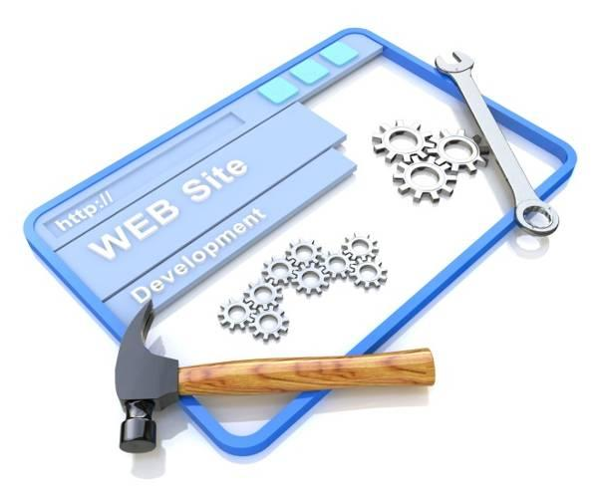
To get started online, you definitely will do well to have an online store, website, or blog - in addition to using social media such as facebook, Pinterest, and other social platforms for your business.

When it comes to an online store or website - If you have never built one before, then it will take time to get it going. Don’t let building a website intimidate you though. Someone can help you or you can always pay a company to do so. Before you just find any company to do this, if you have our information, you can always contact us about it.

We will talk about other methods of presenting your company on the internet in the following chapter. But having a store is going to be the most solid presence you can have for your company as of now because it brands you. In fact, there are many sites out there that will let you build one for free. I would start there because that way you can use trial and error in order to get it done.

WORDPRESS

Ted - In my opinion, WordPress Blogs are some of the easiest to work with, especially if you are new. I wish I would have known about them when I got started.

I actually got my online presence going back in 2005 with one of the cheesiest looking blogs. I had no idea what I was doing, but I somehow managed to pull one together. The blog was free, it was one that I made through Blogger.com (Google Blogs). I put together the site with a sales page, images of the furniture I built, and when you clicked on the images you went to the payment page where the customers would pay through PayPal.

Over time, I just learned through trial and error on building a site, and got some help from family and friends. So the site evolved and started to take shape. During that period I was still selling on eBay, and my site was getting established naturally in the search engines, and I was getting traffic to the site.

This is a route that you will have to figure for yourself which way to go. But it takes time for this to happen unless you want to pay a company a large chunk of money to take over getting traffic to your site. So what other options are there?

PAY PER CLICK ADVERTISING

Here is an option that has exploded today. Pay per click advertising. When first starting off, you have to make sure that you don’t go with the big companies like Google. If you do, you will end up paying upwards of 2-3 bucks a click. That can get expensive, especially because usually it takes between 10-50 or more clicks to gain a return. If you are at the high end of the margin and it is 2.00 a click in Google, then that could be 100 dollars or higher for a sale. That is not a good option if you are only selling a product for 150-200 dollars including shipping. So what other areas can you explore?

SHOPPING ENGINES

They have plenty of “shopping engines,” or technically they are called “comparison shopping engines” that offer pay per click advertising at a fraction of what Google and even Yahoo or Bing offers. I used a number of them for a long time, and they yielded great returns.

I usually paid on average about .35-.40 cents a click. You can even bid on clicks as high or low as you want. I found that bidding higher never helped much at all. It was always about the same if you just went with an average median rate. So just from my experience with it, I would say start in the middle before going higher or lower.

Here are some examples of the Shopping Engines:

Amazon Handmade
Etsy
Zibbet
Pricegrabber.com
Shopzilla.com (also known as Bizrate.com)
Shopping.com
Nextag.com
Amazon.com
eBay.com (already mentioned of course)
RubyLane.com
Bing Shopping
PriceFalls.com
Pronto.com

There are so many others out there though. And new engines are added on a regular basis. I experimented with a number of these before I settled with four of them. I went with PriceGrabber, Shopzilla, Nextag, and Amazon. I found those to give the best return (ROI), but it is all going to depend on a variety of factors; what product you have, how much of a demand that revolves around your product, and much more. This aspect will take a few months to get a grip on what is best for you and your company.

But if you are new it’s good to learn to use social media marketing to generate free traffic to your online store, site, or blog - and you also may have to advertise at first because it takes time for your site to get established in the search engines such as Google, Yahoo, and Bing. There is almost always an upfront cost when you advertise. There is another method though that many use today. It can cost as little as…..free. Once again we are talking about Social Media.

CHAPTER 6: USING SOCIAL MEDIA TO CREATE CUSTOMERS

Social Media is definitely important these days to your internet business. That is because this generation is engrossed in it. And it doesn’t seem to be changing anytime soon.

Social media really started gaining greater momentum 10 years into this millennium, and has been rolling ever since. And something even better is you can start it off free. Of course, just going with a little paid influence in social media can go a long way.

Most know what social media is, but to be specific, we are talking about different social engines and networks such as Facebook, Twitter, Pinterest, LinkedIn, Google +, and Tumblr. There are quite a few more, but you get the drift. With these forms of media, you are able to get a TON of traffic to your internet store, website, blog, or whatever online presence you have.

Now, if these networks are such a great source of traffic, why not just use these and nothing else? Because while social media is established, it is ever changing. If you have your own site though, you are the one that determines if changes are going to need to be made or not.

In addition to this, social media comes and goes. A social network can be running your business at full throttle and then they make a decision that chops you off. So the best thing is to use these as tools to drive traffic to your site, and never have just one as your main source of customers. You need to have a mixture of customer funnels through these networks.

Here is just one of many experiences. I was talking with a woman that was gaining great momentum with her business on eBay. She was keeping her local post office busy sending out a lot of packages, gaining return customers, perfect feedback, etc… Though eBay is a shopping comparison engine, and not social media, you can have similar backfires to what happened to her.

eBay, again, was her sole source for her business. She started making a large volume of sales, so she did what most businesses would do. Reinvest in larger amounts of the inventory that sells. She had a room full of her different items that she sold. Then, in one day, her business went belly up. What happened?

eBay made a change in their algorithm and placed all the larger volume sellers at the top of their searches. As an example, one of her items was a wedding cake topper. She sold those on a regular basis because eBay was mixing everyone together in the search. Well, as a business decision, they wanted the top sellers to be located at the top. They changed the search to what they called “best match.”

Which makes sense if you own a business, you want your top performs at the top because they make the company more money. But the little guy was squashed with that. Now if you had eBay as ONE of your sources of revenue online, then when a change like that is made, you can pick it up from somewhere else. And this can apply with the various social media networks out there as well. Use as many different ones as time allows you to, and when one falls (and eventually it will fall and be replaced with something new) – you have the others as backup.

As mentioned previously, you can actually have a paid campaign on a social media network. We will use Facebook as an example because they are still huge as of now. You can actually pay for likes to your Facebook Page, and as low as pennies a like. There is a lot of pit and pat out there as to if you get decent traffic with paid likes, but from what I have experienced, it depends on the content you put on your page.

POSTING WITH SOCIAL MEDIA

Social Media is such a success because people like to have easy access to information on things they like and can use. They also like to be entertained with trivia, self-improvement, insight into their hobbies, and more. Therefore, when you post on these pages, you will want to do so in a regular manner.

That way your audience will know that they can keep going back to your page with new information they are really interested in. But, it has to be more than regular. It has to be informative, well written, and something interesting. Images are a must, but always use the proper attribution if it isn’t an image you bought or made yourself. Make sure that you are actually allowed to use it even with attribution. You don’t want a lawsuit on your hands over a picture. This happens every day, so don’t chance it.

Once you start to get a captive audience, it can snowball. That is because one person will share it with another, and they in turn will share it with someone else, and so on. But will they share bland material? Would you? NO WAY! And you don’t have to be an authority with your subject material, but it does help to know your stuff! With just a little research, you can find so much new insight into your subject across the pages of the internet.

Just do a search on the subject in Google or any other engine, and once you find different subtopics about your topic, then you can put those in the searches as well and it will get so extensive that you NEVER will run out of things to add. I cannot overemphasize how important it is to be regular with the posting to the social media. Daily if possible, but 3-4 days a week is a minimum.

POSTING INFORMATION? SO WHAT? WHAT GOOD DOES THAT DO?

Ok. This question above may have run across the minds of many. Why would I just post this free information to people? What good does it do for my business? It has a lot of power. Here is what we have found when working with social media.

You want to slip your site in from time to time. Don’t overdo it though. If you mention go to my site to see this or that on every post, you will quit getting people coming to your social media pages. They usually look at that as an advertising gimmick, or just plain and simple don’t want to have to click around to get more information.

But, if you slip it in once a week, or two times every 3 weeks – people will be more likely to go there because you aren’t bombarding them with “go here” and “go there” all the time. Also, let’s say you are selling products on your site, and that is all that is on your pages – your products.

These individuals aren’t going to click on your links much at all if this is all you post, because they were probably not going to your social media page to buy something in the first place. The main reason people use social media is not to make purchases, but to get entertained, to find knowledge, and to see what their old friends and new are up to. So you have to be subtle with it.

Once you have established a paid campaign with your social networking sites, over time it is very possible (if done correctly) that you won’t have to pay anymore. That is because you have already gained a lot of followers, and if the posts are well written, great information, with great images – then you will continue to get more individuals that share you with their friends, who then will share with their friends, and it will then NATURALLY have a continuous cycle.

Again, don’t let any of this scare you. You may have a family member that can help you with it, and also it is possible that I can help you if you know my contact information.

Okay. With that out of the way, we need to get back to the note that ended in chapter 5. What if you don’t have the setup to build your own product? Or if you don’t have the time to make the product, or aren’t interested in making anything, what can you do?

CHAPTER 7: FINDING DROPSHIPPERS FOR PHYSICAL PRODUCTS

There are many individuals out there, that don’t touch the products that they sell. As easy at this seems to be, that isn’t the case. Once you have gotten everything established and running, it does have its benefits. But there are still things to keep in mind when going this route.

First of all, you have to do quite a bit of footwork in the beginning to find one or more drop shippers that you can trust to not only perform the task, but to do a good job each and every time. Once again I am going to give you an example of what I went through when expanding my business.

Ted - I had it from both ends. I let it get way out of hand for a few years, and we were getting far too much business for me to handle by myself. So I started getting some help in the shop. It still wasn’t enough. So I had to try to send the business to others that could fill the orders for me, but where I still could make money on each piece of furniture that I sold.

I got online and found a company that built outdoor furniture. They had been running for a while, and they were wholesalers. They seemed to fit the bill, so I called them and we struck a deal. Fortunately things got going with them and they became my first drop shippers that I used.

I received the order from my site, I would email the company the item that sold, and they would fill the order and ship it. So it worked out. I had another company that I got to do the same thing because I just couldn’t do it all myself. Then, throughout the years I would get calls and emails from companies wanting me to be a drop shipper for them! I would actually do it at an almost retail price and turn around and just send it to my drop shipper who would do it at a wholesale price.

So the potential is there to really grow with your online business using dropshippers.

One more issue with drop shippers – Your reputation is on the line. So if they do shoddy work, or don’t run properly, it is still considered your fault. Your customers won’t return to you. Again, the main issue is that drop shipping sounds easy, but can result in more work than you realize. Customers will be upset at you, not the one shipping the product.

So there is good in bad in both endeavors, but that is the case pretty much with anything that you do.

IN CONCLUSION: WHERE WILL YOU END UP?

We thought the image to the left was a good one for the conclusion of this report. That was a good bit to funnel into your brain at once. But in the decade or so that I have worked for myself, I have found that you will learn a thousand times more than what you read here.

In all seriousness, these are definitely just the basics that have been explained to you. Even though you can get started with a business online such as I did, turning your hobby into a career, you will evolve as a company. Getting it up and running is not a difficult process, and it doesn’t take long to get it going. But some key points that you need to remember are:

- Do Your Research – Make sure that you can produce or find a product that sells. There are so many ways to find this out, just a few were mentioned here.

- Build An Online Presence – Establish your company with an online store, website, blog, or other solid location.

- Get Traffic To Your Site – Using pay per click, social media, and other shopping engines to get people to your location online. Remember, there is a reason that the majority of companies advertise. If done correctly, it ultimately will pay in the end.

- Get Help If Needed Or Wanted – You don’t have to do all the work yourself. There are plenty of companies and individuals out there who want people like you to use people like them.

- Don’t Quit Your Day-job Until You Are Established – Though we didn’t talk about this, I am a realist. I think it ultimately pays in the end to plan ahead first, before you say “Bye-Bye” to your employer. Some have done this and regretted it later on because it took a little more time to establish themselves then they anticipated.

- Just use good judgment with this pursuit. Gain contacts and friendships. Today, that isn’t difficult because of the internet. In my experience, if you are an upright and honest individual that plays right, you will have people come to you over time. I had so many opportunities I had to say no to because I didn’t want to be big.

Just keep these practical things in mind and you can take any hobby or skill you have such as sewing, and turn it into a money making business!

